HELLOHIVE
━━━━━━━━━━━━━━━━━━━━━━━━
TECHNICAL ARCHITECTURE
Prototype Platform
OVERVIEW
HelloHive runs on a focused AWS stack optimized for speed to market and operational clarity. Three services, one codebase, zero unnecessary complexity. This architecture validates fast and scales cleanly.
Core Infrastructure: EC2 • DynamoDB • S3

Architecture

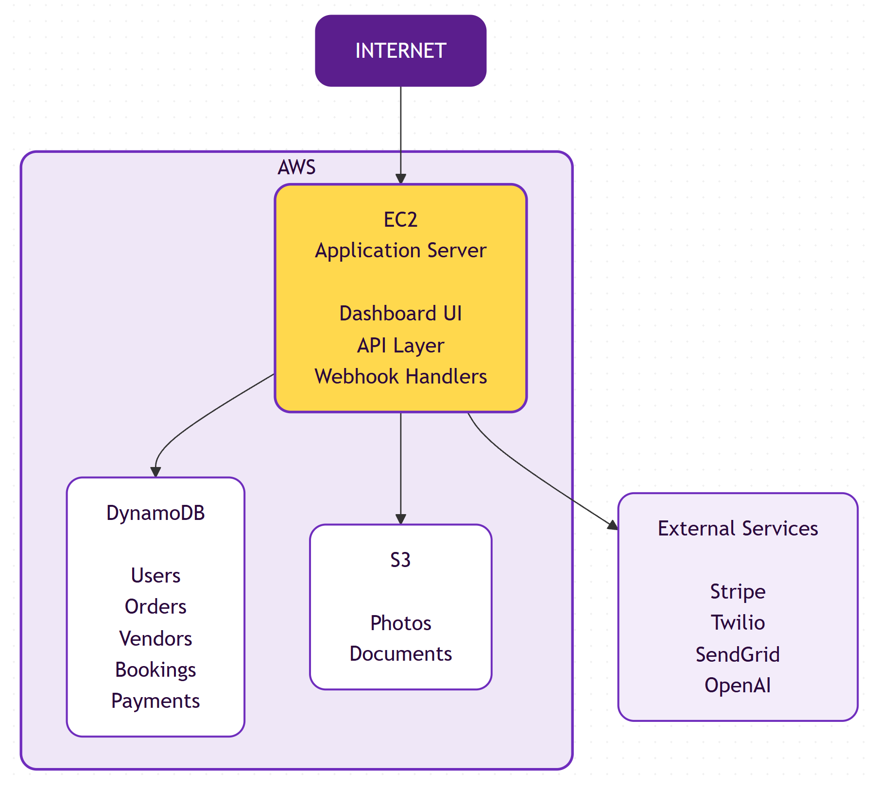

Design Philosophy
We ship a monolith. One Next.js application handles the UI and API layer. This is the right architecture for this stage—fast to build, easy to debug, simple to deploy.
Microservices add coordination cost. We avoid that until scale demands it. When extraction makes sense, the codebase is structured to support it cleanly.

Infrastructure

AWS Services
Service | Role
EC2 | Application server. Hosts the Next.js platform with controlled deployment via version control.
DynamoDB | Primary data store. Users, work orders, vendors, bookings, payments. Fully managed, auto-scaling.
S3 | File storage. Proof-of-work photos via time-limited, scoped upload tokens.

External Integrations
Service | Purpose
Stripe | Vendor payouts via Connect. Test mode for prototype, production-ready architecture.
Twilio | SMS dispatch and inbound handling via verified webhooks.
SendGrid | Email delivery for vendor notifications.
OpenAI | Voice transcription (Whisper) and structured data extraction (GPT).

Technology Stack
Component | Technology
Language | TypeScript — full-stack type safety, single language across the codebase
Framework | Next.js 14 — App Router, Server Components, Route Handlers
UI | React with Tailwind CSS
AWS | SDK v3 — DynamoDB and S3 clients
Payments | Stripe Connect — vendor payouts and platform billing
Messaging | Twilio (SMS) and SendGrid (email)
AI | OpenAI — Whisper for voice-to-text, GPT for work request extraction

Security Baseline
Production-grade security from day one:
• Least-privilege IAM — scoped to required resources only
• Encryption at rest (DynamoDB, S3) and in transit (TLS everywhere)
• Webhook signature verification on all inbound requests
• Secrets isolated at environment level, never in code
• File uploads governed by time-limited, scoped tokens

Prototype Scope
Real infrastructure. Simulated vendors. Full workflow coverage.
PRODUCTION INFRASTRUCTURE | SIMULATED FOR DEMO
• AWS compute, storage, database  • Stripe Connect (test mode)  • Twilio / SendGrid messaging  • OpenAI extraction pipeline  • Full dashboard experience | • Vendor accounts (seeded data)  • Vendor responses (auto-responder)  • Proof-of-work submissions

Post-demo, we swap simulations for live vendor onboarding. Infrastructure stays the same.

Designed for Evolution
Minimal today, scalable tomorrow. Key decisions support clean growth:
• Stateless app layer — horizontal scaling without refactoring
• Multi-tenant data model — customer expansion built in
• Abstracted integrations — swap providers without rewrites
• Infrastructure expands only when load justifies it

Delivery Timeline
Week | Milestone
1 | Infrastructure provisioning, application scaffold, authentication, initial deployment
2 | Dashboard interface, work order management, data model implementation
3 | AI extraction pipeline, structured data parsing, human-in-the-loop review
4 | Vendor management, matching algorithm, dispatch system (SMS + email)
5 | Simulated vendor responses, booking confirmation workflow
6 | Stripe Connect integration, proof-of-work uploads, payment processing
7 | End-to-end validation, demo preparation, documentation

SUMMARY
Simple by design. Secure end-to-end. Production-ready architecture running a prototype workload. Seven weeks to demo, clean conversion to MVP.
━━━━━━━━━━━━━━━━━━━━━━━━
HELLOHIVE • Technical Architecture • January 2026

